**Problem 1**

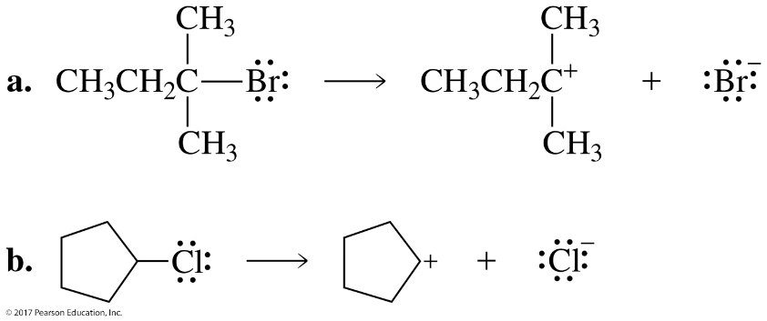

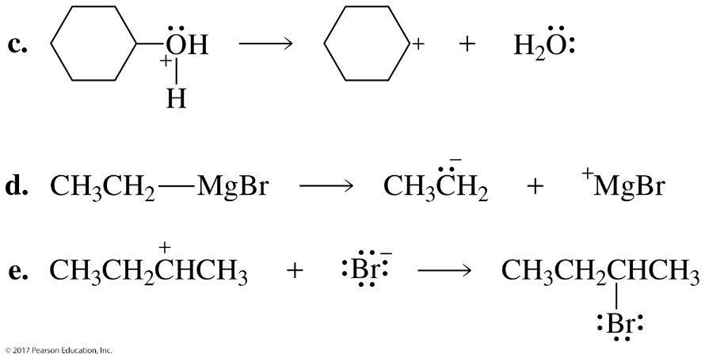

**Problem 2**

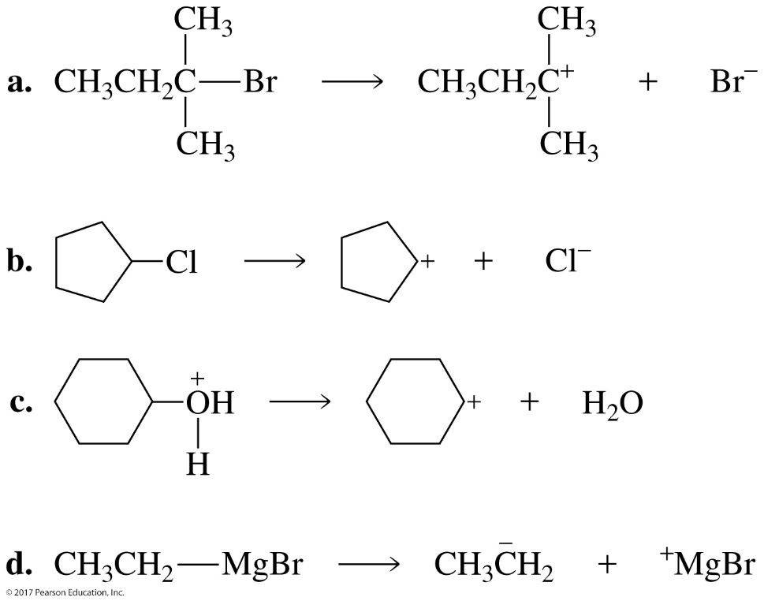

**Problem 3**

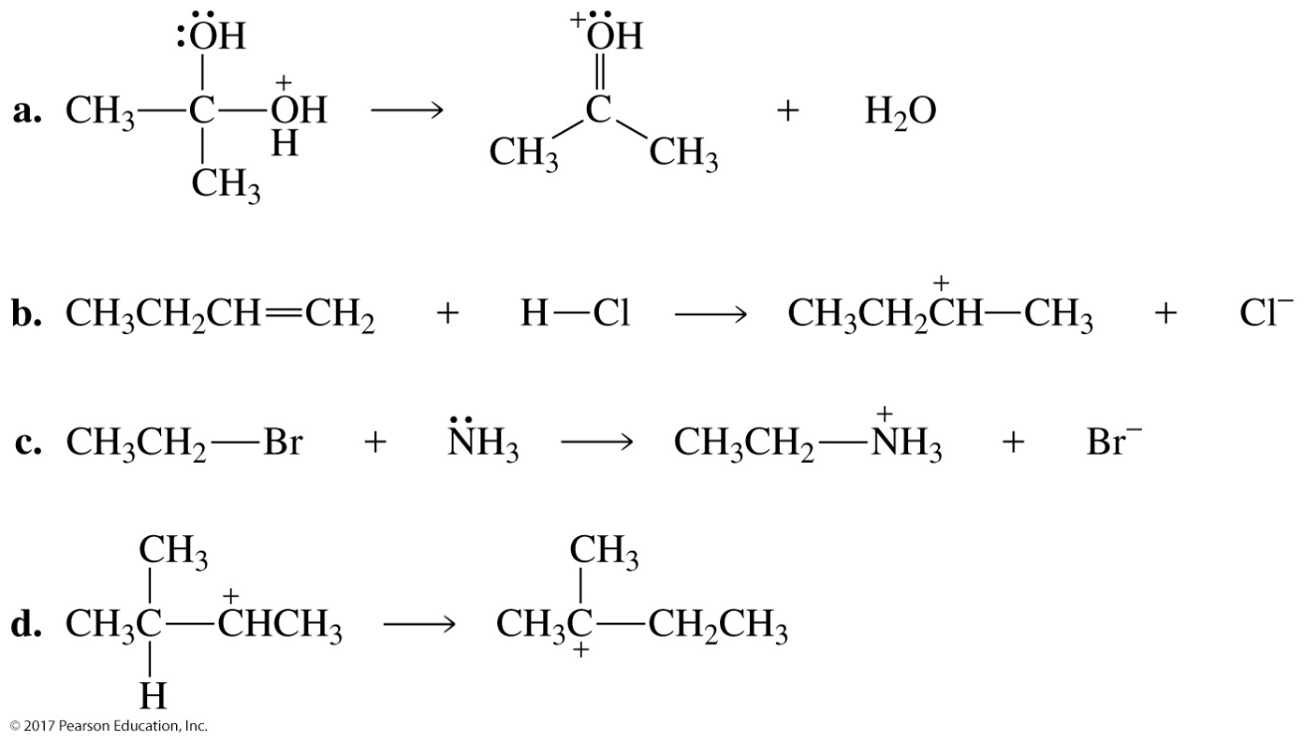

**Problem 4**

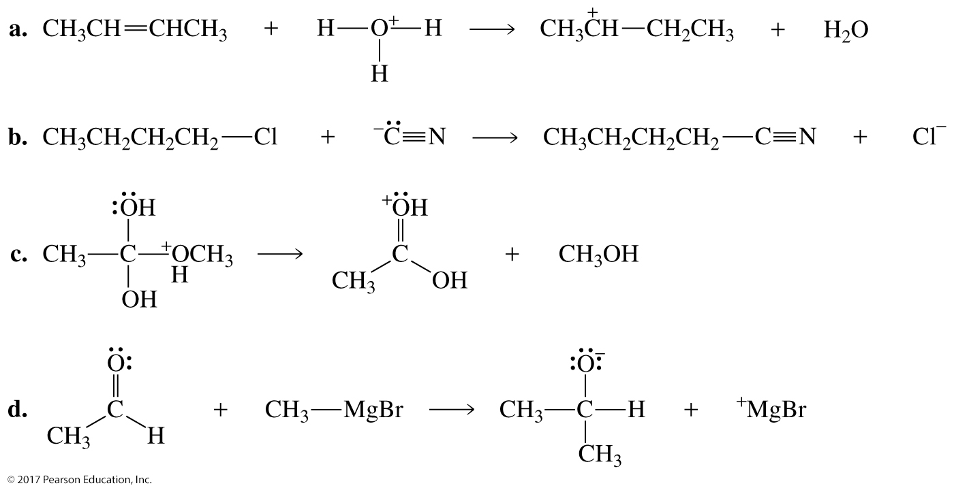

**Problem 5**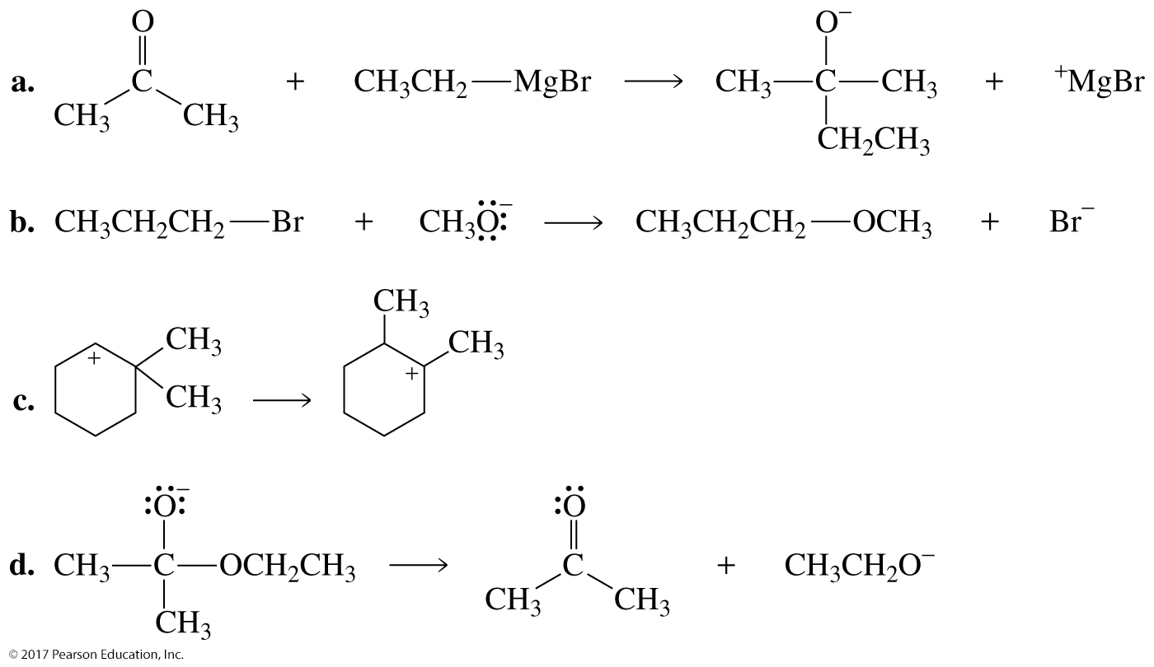

**Problem 6**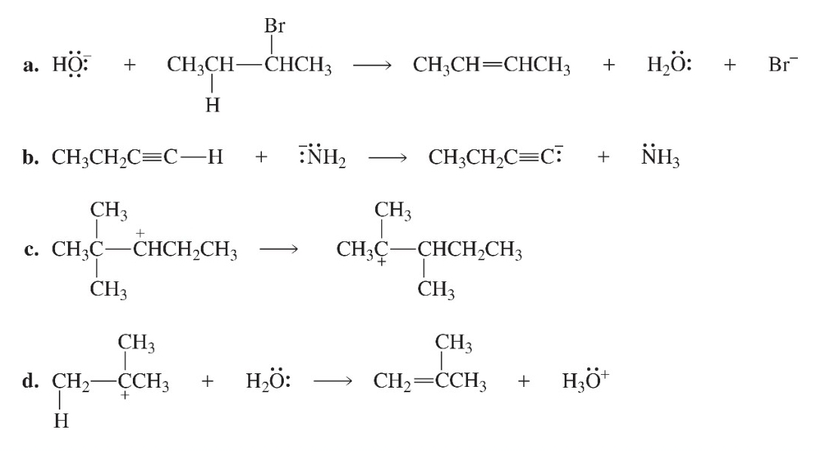

**Problem 7**

**

**Problem 9**

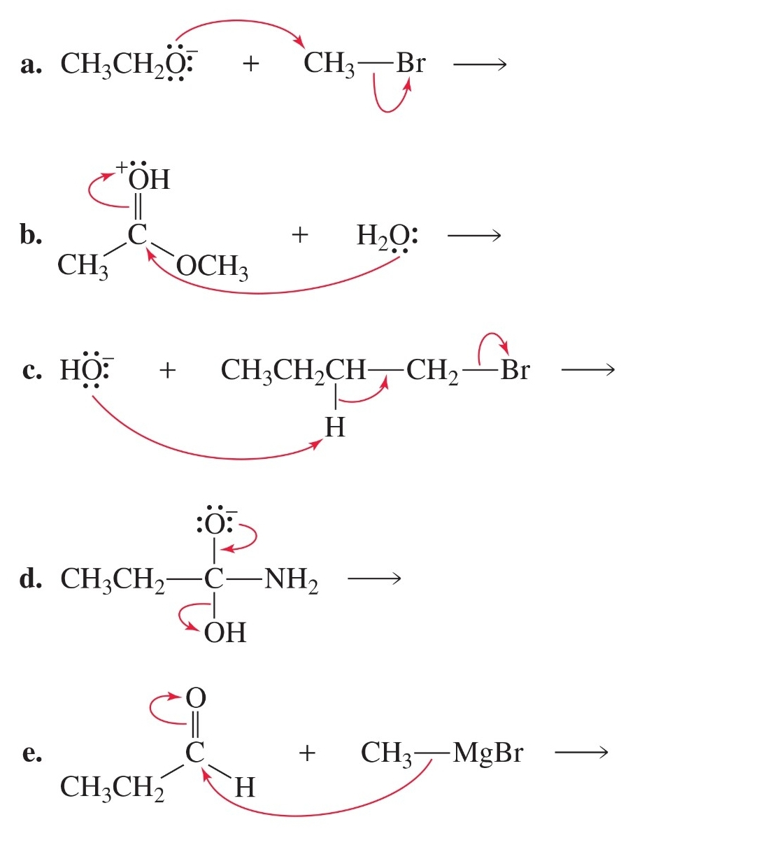

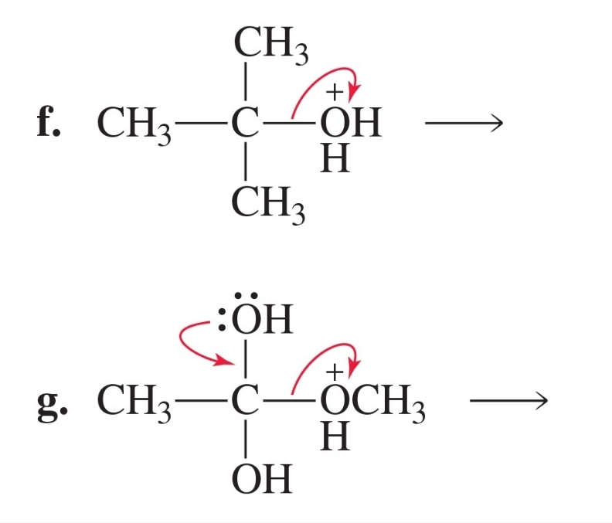

**Problem 10**

